**Assignment 1**

1. **Describe the basic properties of remote sensing with radar in terms of measurements of the distance and speed.**

**Measurement of Distance**

* Radar uses Transit time methodology to calculate the distance between object of interest and radar signal transmitter
* Signal transmitter transmit short pulse of radio signal, any object in path it reflects back the wave, Signal receiver detects the reflection and radar processing unit calculate distance of object by using transit time and speed of wave.
* Generally radar can’t use transmission and reception function, Duplexer is used to switch between transmission and reception at predetermined rate.
* Minimum range of radar = (length of pulse*speed of light)/2.
* Time between two pulses determine the maximum range of radar.

**Measurement of Speed**

* Speed is measured in Radar system by using memory capacity. Change in distance of an object is calculated with respect to time.
* Manual speed calculation using drawing on radar screen was practiced but modern radar uses computers for speed calculation operations.
* Modern radar systems also use Doppler effect for instant speed measurement. It can only calculate the relative speed of an object by shifting the return signal from it’s base frequency.
* Doppler effect-based radar can only measure the component of velocity parallel to the line of sight and can’t measure perpendicular component of the velocity.
* Speed calculation using Doppler effect.

f ’ = f * (1-s/v)

where,

f ’ is return frequency

f is sending frequency

s is speed by which target moving away from radar

v is speed of propagation of pulse (approx. equal to speed of light)

* CW radar uses pure signal of frequency to measure the radial component of target velocity.

1. **What are the main principles of real aperture radar and synthetic aperture radar? State and explain the key advantages of synthetic aperture radar over real aperture radar for radar imaging from space.**

**Real Aperture Radar (RAR)**

* In range direction at perpendicular to the flight direction, known as azimuth direction, transmitter transmits narrow angle beam of pulse radio wave.
* Reflected pulse arranged with respect to return time which relates to azimuth direction.
* Backscattering received from the target and processed into radar image.
* Resolution of image is dependent on pulse width.

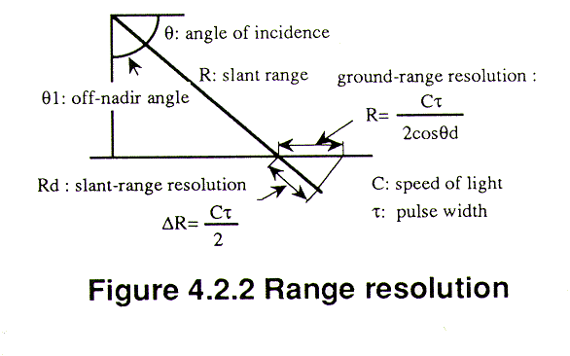

Figure 1 Range Resolution Source: http://sar.kangwon.ac.kr/etc/rs_note/rsnote/cp4/4-2-2.gif

* To create balance resolution and transmission power the transmitted pulse is modulated to ‘compressed high intensity radar pulse (CRIP)’ with high power and wide band. The pulse is received through a matched filter with de-criping function to make pulse width high power and narrow.
* Azimuth resolution = (wavelength*distance)/aperture

**Synthetic Aperture Radar (SAR)**

* Synthetic Aperture Radar (SAR) is a type of radar that uses motion of radar antenna to create a 2D images or 3D reconstruction of objects.
* It is typically mounted on aerial vehicles or satellites. Generally, image resolution is dependent on aperture size of antenna, SAR uses a moving antenna to create synthetic aperture for high resolution image.
* EM waves are transmitted in a sequence, echoes are collected and processed by a system.

**Advantages of Synthetic Aperture Radar over Real Aperture Radar**

* SAR provides better resolution due to synthetic large aperture.
* The synthetic aperture produces better result by targeting multiple radar pulses on the object of interest.
* Result of SAR can be rendered into recognizable terrain map.
* Shadowing isn’t present in SAR while in case of RAR, shadows are present due to atmospheric scattering.

1. **Give an account on the formation of structure of the ionosphere and its impact on the remote sensing and communications using electromagnetic waves between satellites in orbits and the Earth’s surface.**

Ionosphere is upper part of Earth’s atmosphere extended from 48 Km to 365 Km altitude. The ionosphere is ionized due to solar radiations and influences radio propagation.

Ionosphere is divided into 4 layers (D, E, F1, F2) during day and 2 layers during night (E,F)

**1.D layer**

Region: 48 Km to 90 Km above the earth surface

Cause of Ionization: Lyman series-alpha hydrogen radiation (wavelength 121.6nm) ionization of nitric oxide

Impact on Remote sensing and communication:

* Medium Frequency and Lower High Frequency waves effected in D layer.
* Waves cause electrons to move that lead to collision with neutral molecules and loss of energy.
* Lower frequency experience greater absorption.
* During solar proton event, increased ionization enhances the absorption of radio signals.

**2.E layer**

Region: 90 Km to 150 Km above surface of Earth

Cause of Ionization: Soft X-ray and far ultraviolet ionization of oxygen

Impact on Remote sensing:

* During oblique incidence, Reflect radio waves with frequency lower than 10 MHz
* During Sporadic E event, can reflect upto 50 MHz
* At night, weaker due to lack of ionization.

**3.F1 layer**

Region: 150 Km to 220 Km above surface of earth

Cause of Ionization: molecular ions of O2+ and NO+

Impact on Remote sensing:

* At daytime, It reflect radio waves up to 30m wavelength.

**4.F2 layer**

Region: 220 Km to 800 Km above surface of earth

Cause of Ionization: O+ atomic ions

Impact on Remote sensing:

* F2 is reflecting layer for High frequency radio waves during day and night

1. **Describe the main mechanisms of the atmospheric absorption, scattering, and transmission** **of the solar radiation and its reflection by the ground objects. Discuss their** **effects on the natural phenomena as perceived by human eyes and on passive remote sensing in the optical spectrum of the EM waves.**

* **Absorption**

Absorption is the phenomenon in which radiation is retained by constituent part of atmosphere leading to reduction in intensity. Energy absorbed by the atmosphere is radiated at higher wavelength.

There are mainly three absorbers present in atmosphere:

Ozone: It absorbs waves with UV wavelength.

Carbon Dioxide: It absorbs waves with Mid and Far infra-red wavelength.

Water Vapour: It absorbs waves with far Infra-red wavelength.

* **Scattering:**

The processes of redirection of EM waves by particles suspended in atmosphere is known as Scattering. The amount of scattering is dependent on size and quantity of atmospheric particles, depth of atmosphere and wavelength of the wave.

Scattering is categorised into 4 types:

**Rayleigh:** Caused by particles smaller than wavelength of radiation, found in upper atmosphere.

**Mie:** Caused by particles with size equal to wavelength of radiation, found in lower atmosphere.

**Non-selective:** Caused by particles with much larger size than incident radiation wavelength. Amount of scattering is not wavelength dependent.

**Raman:** Occurs when photon has elastic collision with molecules, result in gain or loss of energy. It can increase and decrease wavelength of radiation and particle size dependent.

* **Transmission of the solar radiation:**

Transmission of solar radiation is wavelength dependent. Different gasses cause absorption of different wavelengths.

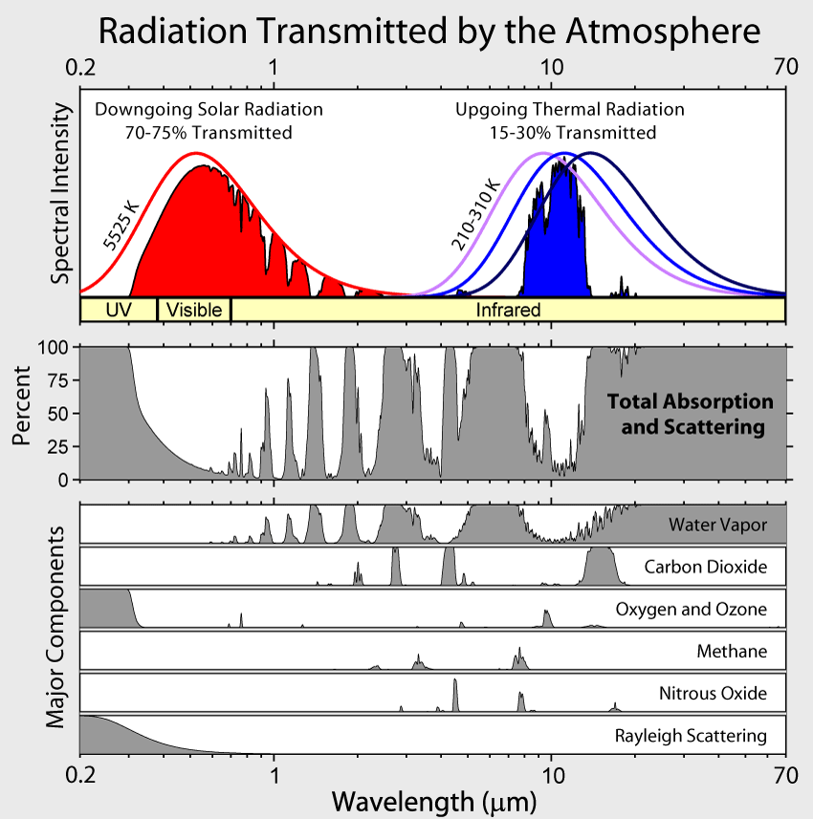

Figure 2 Radiation Transmitted by the Atmosphere

Source: https://en.wikipedia.org/w/index.php?title=Image:Atmospheric_Transmission.png&redirect=no&oldid=138013407#/media/File:Atmospheric_Transmission.png

* **Reflection of Solar radiation by ground objects:**

Different surfaces and objects absorb certain amount of solar radiation or energy, after certain amount of time they reflect all of it or part of it back to the atmosphere this is known as reflection of solar radiation. ‘Albedo’ represents the percentage of reflected solar radiation by any object. A perfect black and white body has 0 and 1 albedo respectively. Earth’s average albedo is 0.3, so 70% of solar radiation is absorbed by the surface of earth.

**Effects of the natural phenomena on solar light as perceived by human eyes:**

During morning and evening, Due to absorption of light by atmospheric elements and longer path length the light with lower wavelength is absorbed and scattered. Hence sun appear to be redder and low intense, while during the day it appears to be white and uniform.

**Effects of the natural phenomena on Passive remote sensing:**

Passive remote sensing is source dependent, the main source of radiation for the remote sensing system is sun. The system receives radiation a part by refection from the earth’s surface and part by radiation scattered by atmosphere. The amount of absorption, transmission, scattering determines the quality and quantity of radiation received by the sensors of Passive remote sensing system.

1. **Characterise the key parameters and behaviours of the following types of orbits around the Earth with a simple illustrative sketch of their geometries, orientations, and relative orbiting altitudes. For each of the orbital type, explain why it is particularly suited for what type of space missions for sensing, observation, and/or communications.**
   1. **Low Earth orbit (LEO)**
   2. **Medium Earth orbit (MEO)**
   3. **Geostationary orbit (GEO)**
   4. **Polar orbit**
   5. **Sun-synchronous orbit**

**Low Earth orbit(LEO)**

Altitude: less than 1000Km

* Satellites in LEO do not have to follow particular path, their plane can be tilted.
* Satellites in LEO are most commonly used for imaging, as higher resolution imagery is easier
* International Space station also orbits in LEO, as reachability to LEO is easier comparing to other orbits.
* Communication satellites are not preferred in LEO due to fast movement in space.

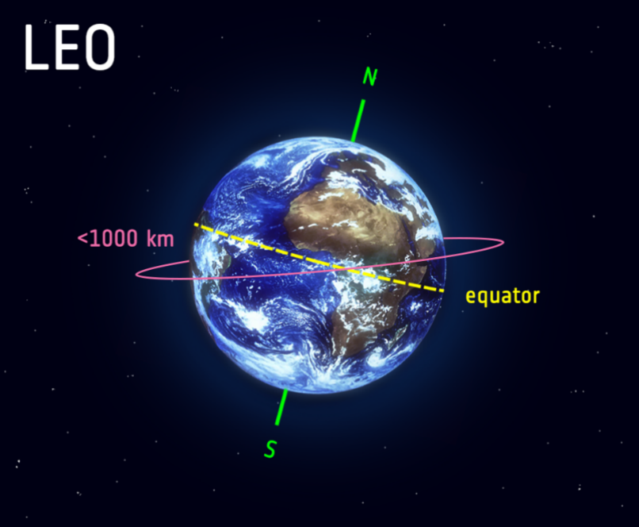

Figure 3 Low Earth Orbit

Source: https://www.esa.int/Enabling_Support/Space_Transportation/Types_of_orbits

**Medium Earth orbit (MEO)**

Altitude: Between 2000 Km to 35786 Km

* MEO is similar to LEO in case of path requirement, a satellite do not require to follow a particular path.
* MEO is commonly used by navigation satellites.
* MEO satellites often work as part of large combination.

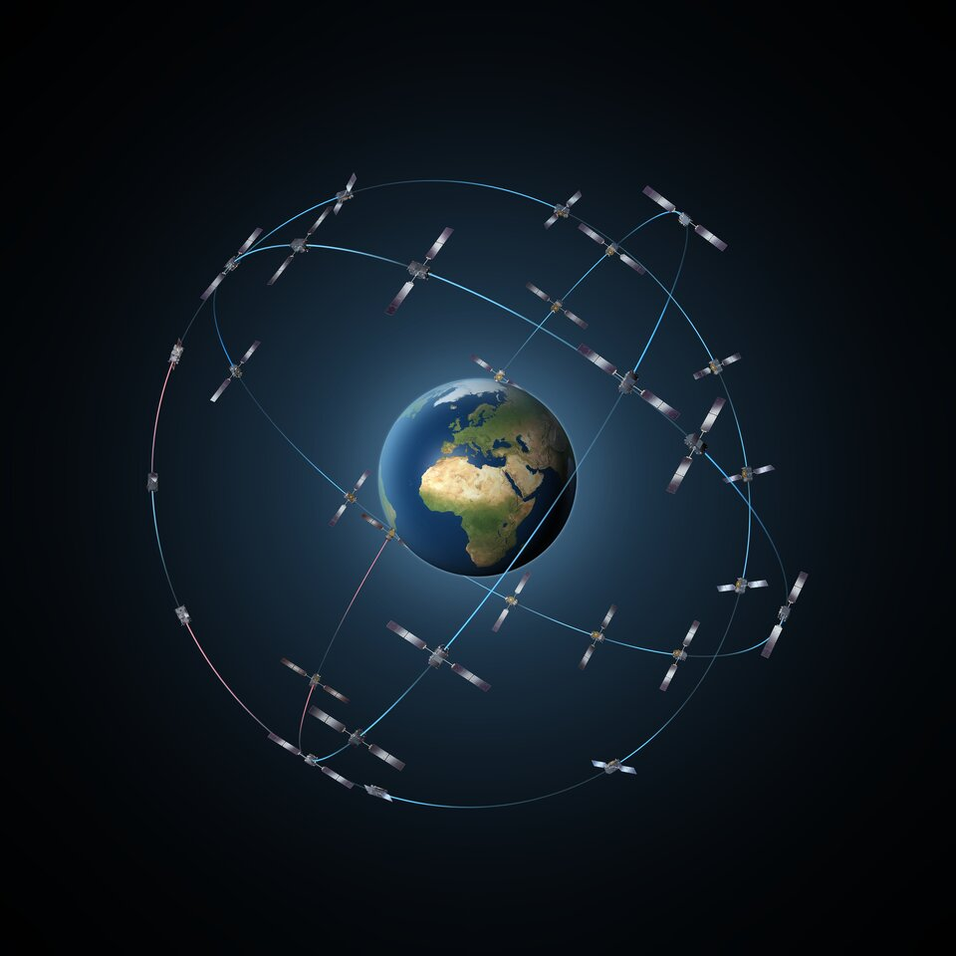

Figure 4 Medium Earth Orbit

Source: https://www.esa.int/Enabling_Support/Space_Transportation/Types_of_orbits

**Geostationary orbit (GEO)**

Altitude: 35786 Km above earth’s equator

Direction of revolution: Should follow the rotational direction of Earth, west to east

* Satellites in GEO must take 23 hour 56 minutes 4 seconds to complete one revolution of the Earth to be stationary relati1ve to surface of Earth.
* GEO is generally used by telecommunication satellites and weather monitoring satellites.
* Three equally spaced GEO satellites can provide near global coverage.

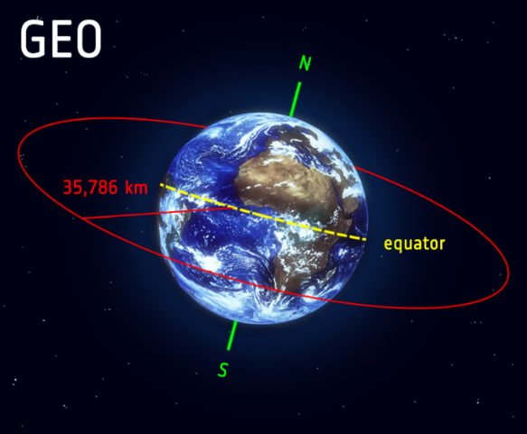

Figure 5 Geo-stationary Orbit Source: https://www.esa.int/Enabling_Support/Space_Transportation/Types_of_orbits

**Polar orbit**

Altitude: 200 to 1000 Km

Polar orbit is satellite path from North to South, passing roughly over the Earth’s poles.

Deviation of 20 to 30 degree in path from path over the pole is considered are Polar orbit.

**Sun-synchronous orbit**

Sun-synchronous orbit is the Polar orbit in which satellite is always synchronised in the same fixed position relative to the sun.

Satellite is always present at same spot at same local time.

It is generally used by scientists studding certain part of world at certain time, by comparing images or data of same place and same time but different day.

Often, SSO are synchronised at constant dusk or dawn.

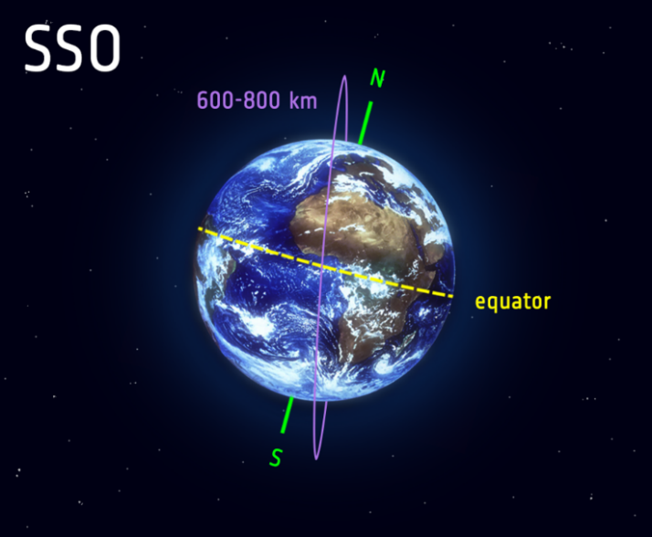

Figure 6 Polar and Sun-synchronous orbit

Source: https://www.esa.int/Enabling_Support/Space_Transportation/Types_of_orbits

1. **Describe the main principles of the Red-Green-Blue (RGB) additive colour system and provide a brief justification of this colour system in relation to the human vision system.**

**Red-Green-Blue (RGB)** is a colour system based on additive colour model. The combination of all three i.e. Red, Blue, Green will result in yield of white colour. In computer system irrespective of software or program being used, 8-bit colour system is used with values 0 to 255 i.e. (R, G, B) could be (0-255,0-255,0-255) where (0,0,0) represent black and (255,255,255) represent white.

The source of energy for Earth is Sun and from the whole EM wave spectrum the visible spectrum combines as white light. Due to the interaction with atmospheric particles and environmental objects the white light disperses in various colours or reflect after some absorption by objects. It is observed in the natural phenomenon of Rainbow, when light passes through moist air then white light disperse into 7 colours i.e., Violet, Indigo, Blue, Green, Yellow, Orange, Red and it is called VIBGYOR. The formation of VIBGYOR is based on the wavelength of different colour. It is observed practically that combination of Blue and Red can result in product of Violet, Indigo depending upon the intensity, similarly Red and Green can produce Yellow and orange, and Green and Blue can produce cyan family. So, by these observations Red, Green, Blue were designated as primary colours as other colours can be generated by combination of three.

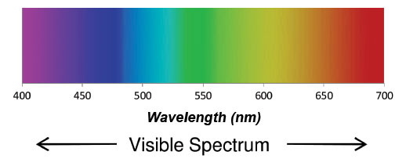

Figure 7 Visible Spectrum Source: https://www.orcagrowfilm.com/Articles.asp?ID=145

The RGB pattern is based on the Reb Green Blue primary colour model, different intensity of different colour will result in change of light intensity and other features of colour.

Human vision system consists of four type of sensors/ Photoreceptors in retina dealing with different wavelength of light. Four types of Sensors are as follows

* Blue-Sensitive Cones: 380-550nm, peaking at 450nm
* Green-Sensitive Cones: 430-670nm, peaking at 550nm
* Red- Sensitive Cones: Major range 500-760 nm, peaking at 600nm; Minor range 380-450 nm, peaking at 420 nm
* Rods: Motion and edge detection, more sensitive than cones to light. Encoded as white covering range of wavelength between 380 nm and 590 nm peaking at 510 nm.

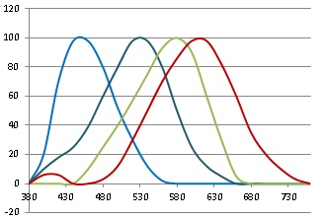

Figure 8 Light sensitivity curves Source: https://midimagic.sgc-hosting.com/huvision.htm

**Image Enhancements**

Location: La Palma Island

Coordinate- Latitude: 28.603, Longitude: 17.8308

Date range: 09/01/2021 to 10/01/2021

Data set: Landsat 8 OLITIRS C1 Level-1

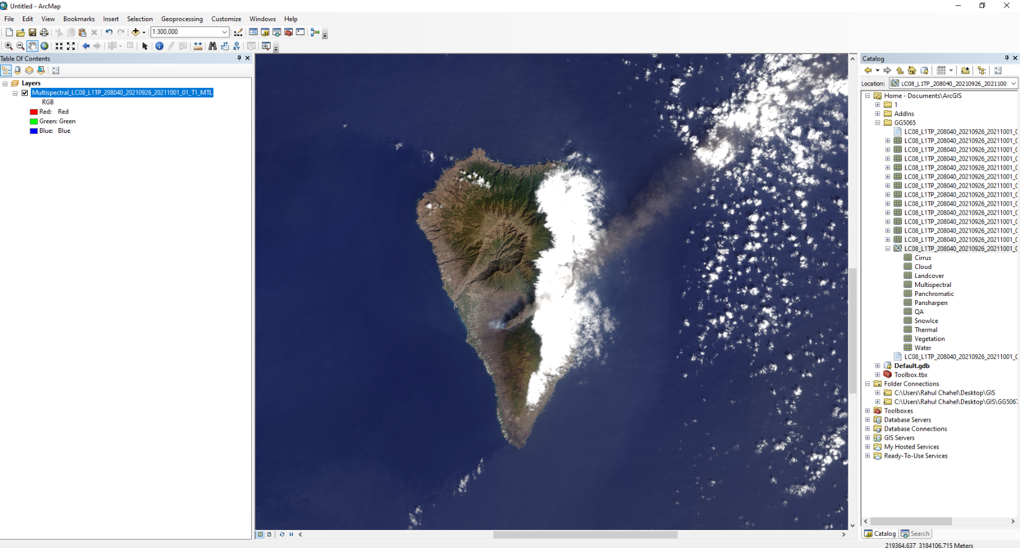

Figure 9 ArcMap 10.8.1 Interface

**Pseudo Colour**

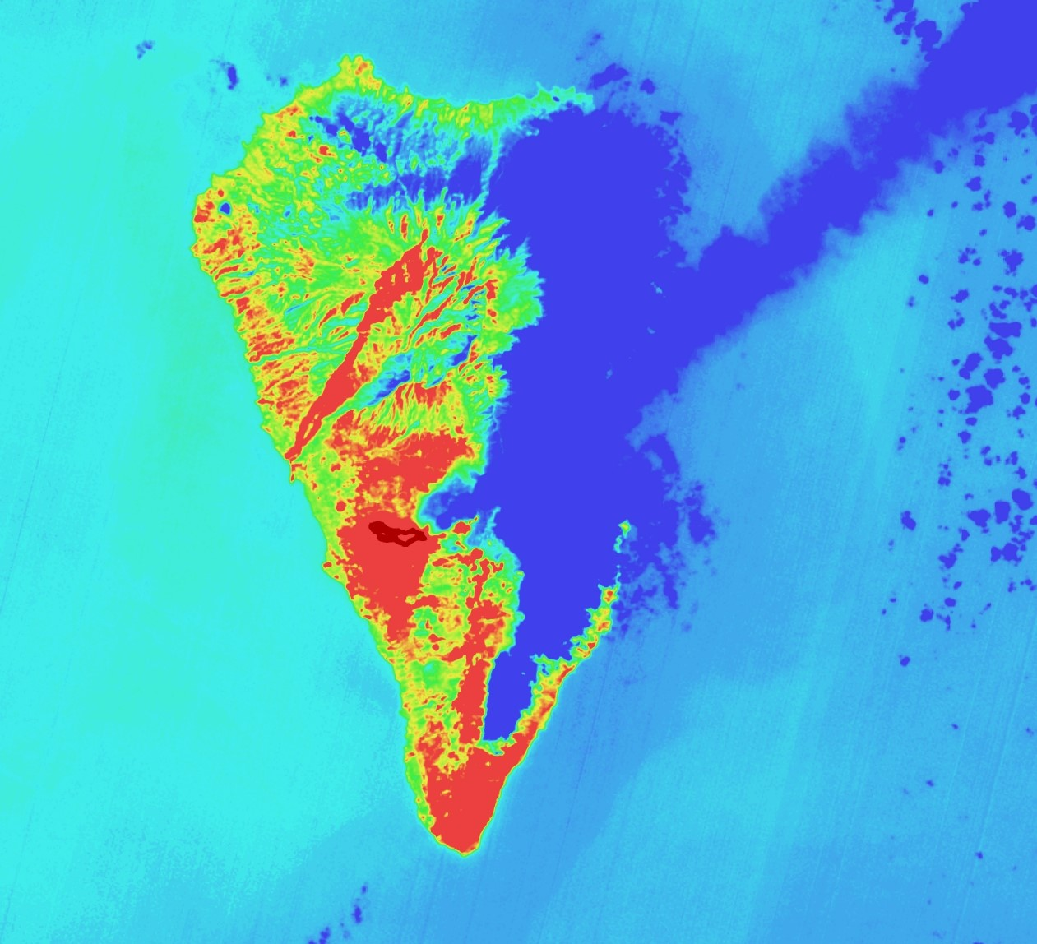

Figure 10 Pseudo Colour map of La Palma Island

**Procedure followed:**

* + - 1. Imported Band 11 TIF file from dataset to blank project in ArcMap 10.8.1
      2. Changed the Colour Ramp to better aesthetic Ramp i.e., Red to Blue. As the Band 11 represent long wavelength infrared map of the island, the Red to Blue colour ramp was perfect to represent hot temperature to cold temperature respectively.
      3. Changed the display parameters like brightness, gamma, contrast from Image Analysis box to enhance the visualisation of temperature difference between areas.
      4. Added new layer for better visualisation of lava flow. Applied Histogram operations using ‘Interactive Stretch Tool’ to make lava flow stand out (as dark red).
      5. Changed the rank of layers to display lava flow on the top and adjusted the transparency of both layers for better visualisation.
      6. Exported the map to jpg format file.

**Features of the Map:**

* Infrared radiation intensity/ temperature visualisation, Hot to Cold area is represented by Red to Blue colour respectively.
* Dark Red colour represent the flow of lava in the region and it could be observed that region surrounding the volcano has hotter temperature than rest of region.

**True colour image**

Figure 11 True Colour Map of La Palma Island

**Procedure followed:**

1. Imported the band 4(red), band 3(green), band 2(blue) using Geoprocessing>ArcToolbox>Data management tools>Raster>Raster processing>Composite Bands.

2. Used ‘Interactive Stretch tool’ from ‘Image Analysis’ Tool to apply the histogram operations.

3.Adjusted display parameters like brightness, gamma, contrast from ‘Image Analysis Box’ to enhance visualisation.

4. Exported the map to jpg format file.

**Features of Map:**

* Geographical features like sea, clouds, terrain are clearly visible and can be easily identified by eyes with combination of band 4,3,2.
* Visible spectrum of light is efficiently visualised by using RGB additive colour system.
* Features like area covered by plants, trees can be observed easily in this combination of bands.
* Smoke coming out of volcano is clearly visible.
* Cloud cover is high above the island, nearly 40% as observed in this exported map.

**False colour image**

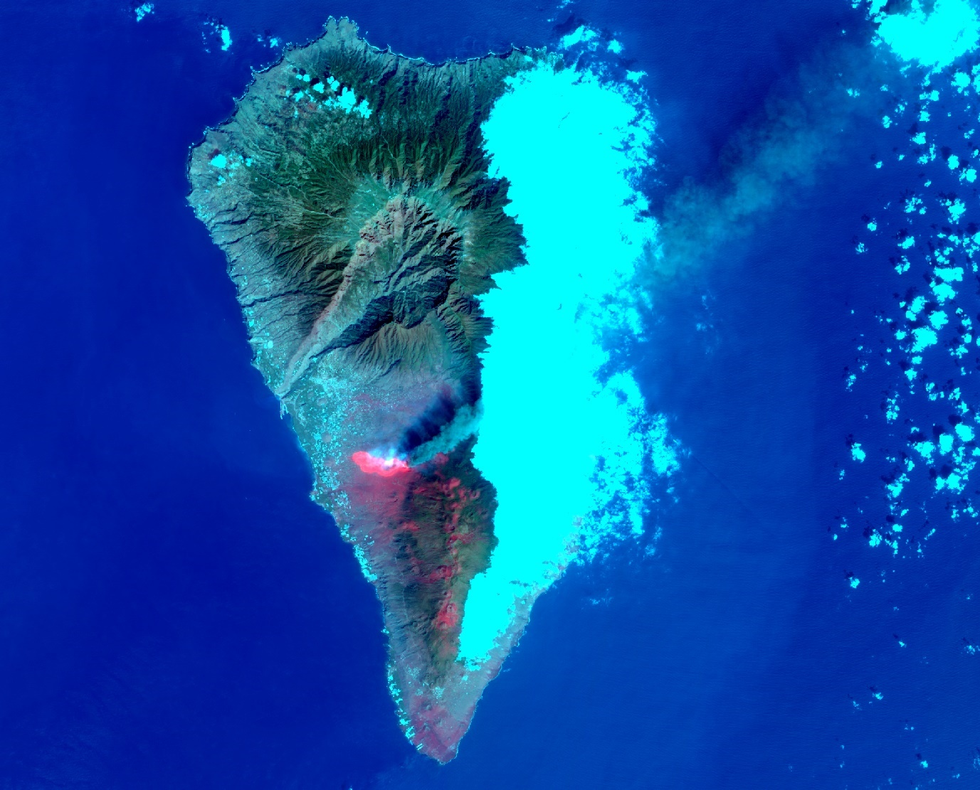

Figure 12 False Colour Map of La Palma Island

**Procedure followed:**

1. Imported the band 11(long wavelength infrared), band 3(green), band 2(blue) using Geoprocessing>ArcToolbox>Data management tools>Raster>Raster processing>Composite Bands.

2. Used ‘Interactive Stretch tool’ from ‘Image Analysis’ Tool to apply the histogram operations to provide better visualisation of lava flow and to create appearance close to true colour imagery.

3.Adjusted display parameters like brightness, gamma, contrast from ‘Image Analysis Box’ to enhance visualisation.

4. Exported the map to jpg format file.

**Features of Map:**

* Better lava flow presentation along with close to true colour imagery.
* Better visualisation of region with very high infrared value/ High temperature with least interference with clouds.

**References**

Barrett, Dick, "All you ever wanted to know about British air defence radar". The Radar Pages. (History and details of various British radar systems)

Buderi, "Telephone History: Radar History". Privateline.com. (Anecdotal account of the carriage of the world's first high power cavity magnetron from Britain to the US during WW2.)

Ekco Radar WW2 Shadow Factory The secret development of British Radar.

ES310 "Introduction to Naval Weapons Engineering.". (Radar fundamentals section)

Hollmann, Martin, "Radar Family Tree". Radar World.

Penley, Bill, and Jonathan Penley, "Early Radar History - an Introduction". 2002.

USAF Long Range Radar, "84th Radar Evaluation Squadron". US Air Force Squadron responsible for long-range Radar Sensor (both civilian and military) operational availability, counterdrug, search and rescue, and flight safety information assurance to the operations community.

Japan Association of Remote Sensing,

Available: <http://sar.kangwon.ac.kr/etc/rs_note/rsnote/cp4/cp4-2.htm>

Robert A. Schowengerdt, Remote Sensing (Third Edition), Academic Press, 2007, Pages 45-XIII, ISBN 9780123694072, <https://doi.org/10.1016/B978-012369407-2/50005-X>.

Types of orbits, The European Space Agency,

Available: <https://www.esa.int/Enabling_Support/Space_Transportation/Types_of_orbits>

HUMAN COLOR VISION,

Available:https://midimagic.sgc-hosting.com/huvision.htm